SUMMER TRAINING REPORT

VERTICAL CLUSTER MEAN FIELD THEORY FOR TWO LANE TASEP

Name: Anup Singh


Submitted to:
Dr. Arvind Kumar Gupta
Assistant Professor, Department of Mathematics


STUDENT’S DECLARATION

I hereby declare that project Titled “ Vertical Mean Field for two lane TASEP” is an original piece of research work carried out by me under the guidance and supervision of Dr. Arvind Kumar Gupta(Assistant Professor, Department of Mathematics, IIT-Ropar). The information has been collected from genuine & authentic sources.This project was undertaken as a part of academic curriculum according to college rules and norms and it has not commercial interest and motive. It is not submitted to any other organization for any other purpose.

Name:
Signature:
Date:

SUPERVISOR’S DECLARATION

I hereby declare that the preparation and presentation of this project work was supervised in accordance with the guidelines on supervision of project work laid down by the Indian Institute of Technology-Ropar.

Name:
Signature:
Date:

ACKNOWLDGEMENT

A summer project is a golden opportunity for learning and self-development. I am very thankful to IIT-Ropar for selecting me as a Summer Intern and allowing me to work on the Project in the prestigious IIT environment. I wish to express my indebted gratitude and special thanks to my supervisor Dr. Arvind Kumar Gupta who in spite of being extraordinarily busy with her/his duties, took time out to hear, guide and keep me on the correct path and allowing me to carry out my industrial project work at their esteemed organization He helped all time when we needed and he gave right direction toward completion of project.
I would also like to thank Mr. Atul Verma and Mrs. Isha Dhiman , for this valuable support , guidance and encouragement throughout my project without whom the project would have not been completed.
Finally, my sincere thanks go to all friends and well-wishers who assisted me in diverse ways to come out with this project work.
I perceive as this opportunity as a big milestone in my career development. I will strive to use gained skills and knowledge in the best possible way, and I will continue to work on their improvement, in order to attain desired career objectives. Hope to continue cooperation with all of you in the future.
Thank you

ABSTRACT

We study the dynamics of a coupled two-channel ASEP in which intra-channel transition rates are dependent on the configuration of neighboring channel. The binding constant k, which signifies the ratio of inter-channel transition rates, is introduced and the symmetric coupling conditions are analyzed for different values of k. The vertical cluster mean-field theory is used to study the system behavior exactly in strong coupling conditions and approximately in intermediate coupling conditions. Additionally, the consequences of particular dynamics such as totally asymmetric simple exclusion process (TASEP), partially asymmetric simple exclusion process (PASEP) and symmetric simple exclusion process (SSEP) in either one or both channels are investigated. It is found that the transition rates have a significant influence on both the qualitative and quantitative nature of the phase diagrams. In this report we took different different injection rates as well exit rates for our two lane TASEP model. We observed that results are independent of different injection and exit rates. In case of strong symmetric coupling our results are found to be dependent on effective injection and exit rates, not on individual rates. The purpose of this report is to provide a complete description of the dynamics of a general two-channel ASEP which is more practical because of
the dependency of intra-channel transition rates on the configuration of the neighboring lane. Our theoretical arguments are in well agreement with extensively performed Monte-Carlo simulation results.

INTRODUCTION
Nature presents plentiful examples of system driven far away from equilibrium. In contrast to the systems in equilibrium, we do not have any general analytical framework which describes non-equilibrium systems in a unified manner. The most important property of a non-equilibrium system is the existence of non-zero particle current in its steady-state. To characterize many-particle systems, it is very important to gain insight about the non-equilibrium steady-states. Driven lattice
Gas (DLG) models are one kind of discrete models which are widely used to study such systems. In DLG, particles interact with their nearest neighbors and hop in a preferred direction. The asymmetric simple exclusion process (ASEP) is a specific
example of DLG and is considered to be the simplest stochastic model for transport phenomena in which particles move along the lattice obeying hard-core exclusion principle with certain pre-assigned rules. Since its inception nearly four decades ago, the totally asymmetric simple exclusion process (TASEP) has become a paradigmatic model in non-equilibrium statistical mechanics. Not only is it one of the few mathematically tractable models in this field, it displays a rich variety of behaviors and provides insight to a range of complex physical systems. Despite their simplicity, these models are competent to efficiently explain some complex non-equilibrium phenomena such as boundary-induced phase transitions, phase separation, spontaneous symmetry breaking and localized shocks, etc.
Single-channel ASEPs have been studied comprehensively and are found to exhibit the aforementioned non-equilibrium phenomena. There exist a large number of real processes such as vehicular traffic, macroscopic clustering phenomena, motor protein dynamics and various systems of oppositely moving particles which comprise particles moving in more than one channel. Therefore, in order to understand the dynamical aspect of many-particle systems more adequately, it becomes important to analyze multi-channel ASEPs. In the last decade, several investigations have been carried out on multi-channel ASEPs. Pronina and Kolomeisky introduced vertical cluster mean-field theory to analyze the role of coupling strength between two channels. Later, the use of this theory made contributions towards the investigation of weakly as well as strongly coupled two-channel systems. Tsekouras and Kolomeisky investigated the role of coupling rates in a coupled TASEP and symmetric simple exclusion process (SSEP). Additionally, several other aspects like symmetry breaking, phase coexistence, phase separation with bidirectional transport and shock formation have been explored in multi-channel ASEP models. Recently, boundary layer analysis has been performed for a two-channel ASEP by Yadav et al. using the fixed point method.

Statistical Mechanics

Equilibrium systems Non Equilibrium Systems
Ising model ASEP model
DRIVEN DIFFUSIVE SYSTEMS
- The macroscopic systems which consists of particles moving in a preferred direction under the action of a driving force are known as driven diffusive systems (DDS).

- Example: Vehicular traffic, in which vehicles move in their desired direction with the driving force produced by its fuel.

- These are of two kinds: Self-driven and Field-driven.

- Vehicular traffic is self-driven system; while electrical current, driven under the field i.e. potential gradient, is a field driven system.

- These kinds of systems can also be found in biological support. Example: Molecular motors. Molecular motors are biological self-driven molecular machines that harness the chemical free energy released by the hydrolysis of ATP in order to perform mechanical work. E.g. Kinesin moves cargo inside the cell away from the nucleus along the microtubules.

DESCRIPTIVE LATTICE MODEL

- A physical model that is defined on a periodic structure with a repeating elemental unit pattern, as opposed to the continuum of space or space-time. We discretize a sample space into small segments (array).

Free space Particle

*The above given figure is a 2-D regular lattice consisting of particles and free spaces.

LATTICE GAS MODEL:

BASIC IDEA: To discretize continuous space into a regular array of cells, known as lattice.

HARD-CORE EXCLUSION PRINCIPLE: This principle states that each lattice cell can occupy at most one particle only.

STATE: The state of a cell is either vacant or occupied. Mathematically, it is defined by occupation number σ,
σ = {1; if cell is occupied
{0; if cell is vacant

CONFIGURATION: The set of states of all cells in a lattice defines a configuration C of the lattice.

Example:

Configuration 1:

Configuration 2:

**Configuration 1is different from Configuration 2.

- Configurations can also be represented in term of 0 and 1 as well.
Configuration 1: {1, 1, 0, 0, 0, 1, 0}
Configuration 2: {0, 1, 1, 1, 0, 0, 0}

MASTER EQUATIONS:

Master Equations are used to describe the time-evolution of a system that can be modelled as being in exactly one of countable number of states at any given time, and where switching between states is treated probabilistically. The equations are usually a set of differential equations for the variation over time of the probabilities that the system occupies each of the different states.

P_{C}(t): It is the probability of finding a system in a particular configuration ‘C’ ‘at time ‘t’.

$$\frac{dPc}{dt}=\sum_{C^{'}}{Wcc^{'}Pc^{'}\left(t\right)-\sum_{c}{Wc^{'}cPc\left(t\right)}}$$

Gain Term Loss Term

**W_{CC’} is the rate of transition from configuration C to C’, which differ by one particle hopping.

MEAN FIELD THEORY:
In physics and probability theory, mean field theory (MFT also known as self-consistent field theory) studies the behavior of large and complex stochastic models by studying a simpler model. Such models consider a large number of small individual components which interact with each other. The effect of all the other individuals on any given individual is approximated by a single averaged effect, thus reducing a many-body problem to a one-body problem.
The main idea of MFT is to replace all interactions to any one body with an average or effective interaction, sometimes called a molecular field. This reduces any multi-body problem into an effective one-body problem. The ease of solving MFT problems means that some insight into the behavior of the system can be obtained at a relatively low cost.

THEORETICAL APPROACH: MEAN-FIELD APPROXIMATION
The basic idea in mean-field approximation is neglecting inter-particle correlations, which simplifies the theoretical computations of solution of the master equations.

NUMERICAL APPROACH: COMPUTER MONTE-CARLO SIMULATIONS
- Are broad classes of computational algorithms that rely on repeated random sampling to obtain numerical results. They are often used in physical and mathematical problems and are most useful when it is difficult or impossible to use other mathematical methods

- The stochastic process is realized on the computer by generating transitions with appropriate probabilities.

- Each simulation step generates one specific realization of the stochastic process.

- Simulations are repeated for sufficiently long time to ensure the occurrence of steady-state.

- Solution is found by taking time average over different simulation steps.

- In general, the Monte Carlo simulations need to be run for 10⁹-10¹⁰ time steps, which is computationally hard.

MONTE-CARLO SIMULATIONS: UPDATE RULES
- RANDOM SEQUENTIAL UPDATE: A lattice site is randomly chosen at each time step and its state is updated as per dynamical rules of the system.

- SUB LATTICE PARALLEL UPDATE: The lattice is divided into sub lattices of size 2 and state of cells is updated in pairs.

- ORDER SEQUENTIAL UPDATE: The state of lattice cells is updated in pairs, either from right to left (backward sequential) or from left to right (forward sequential).

- PARALLEL UPDATE: The rules for hopping, injection as well as removal are applied to whole lattice, simultaneously.

ASYMMETRIC SIMPLE EXCLUSION PROCESS (ASEP)
- The asymmetric simple exclusion process (ASEP) is an interacting particle system introduced in 1970 by Frank Spitzer in Interaction of Markov Processes.

- Is a non-equilibrium statistical physics model with probably one of the simplest rules. Set of rules is chosen according to the postulated dynamics of the system.
For example, people walking along the staircase move one step by step. Corresponding rule would be particles hopping one lattice site at a time .

- The process with parameters p, q≥ 0 , p+q=1.

- Directed motion.

- Follows “hard-core exclusion principle”.

- Inter-particle interactions are neglected.

- Simple and exactly solvable.

- Applications such as Protein synthesis, Surface growth, Traffic flow, gel electrophoresis etc.

In our one-dimensional lattice are labeled by i = 1,…, L. Stochastic evolution dictates that in the time interval [t, t+dt], the particle located on site i jumps with probability pdt to site i+1 and with probability qdt to site i-1 if that site is unoccupied. Generally three types of boundary conditions are specified:

- PERIODIC BOUNDARY CONDITIONS: Sites i and i + L are treated as identical so we can picture the system as a ring (Fig. 1a). To have any dynamics the number of N must be smaller than the sites of the system L.

- Total numbers of particles are conserved.
- Transitional invariant steady state.

Master Equation:
$$\frac{{dn}_{i}}{dt}= <n_{i-1}\left(1-n_{i}\right)>-<n_{i}\left(1-n_{i+1}\right)….(1)$$

Where n_{i} denotes the occupation number of the i^{th} site; i=1, 2, 3… L site.

Taking average over time, we get
$$\frac{d<n_{i}>}{dt}=<n_{i-1}\left(1-n_{i-1}\right)>-<n_{i}\left(1-n_{i+1}\right)>….(1)$$

Mean field approximation gives:
$$<n_{i-1}\left(1-n_{i-1}\right)> = <n_{i-1}> <\left(1-n_{i-1}\right)>$$

Steady–state solution: For any configuration C,

P_{C} =$\frac{N!(L-N)!}{N!}$

**Where N and L denote total number of particles and total number of sites, respectively.

BASIC DYNAMICAL RULES:
- A particle can enter the lattice with a rate$α$ provided entrance site is empty.

- A particle can leave the lattice with a rate β provided exit site is occupied.

- In the bulk, particle can move to its neighboring site with a rate p towards right and with a rate q towards left.

Figure: ASEP on a one-dimensional lattice with finite length.

- INFINITE LATTICE: Boundaries are sent to ±∞, therefore the system remains sensitive to initial conditions which have to be specified carefully. The system with infinite boundary conditions is represented in Fig. 1b.

- OPEN BOUNDARIES: Here the boundary sites i = 1 and L, are coupled to reservoirs of particles outside the system. It means that if a site 1 (L) is empty, a particle can hop from a left (right) reservoir with transition rate α (β) into the system and if the site is occupied, a particle can leave the system with transition rate γ (δ). An illustration of this system is shown in Fig. 1c. Here the assumption of transition rates being constant is made, meaning that the rates are independent of any physical quantity.

- Density not conserved.
- Broken translational invariance.

Master Equation:
$$\frac{{dn}_{i}}{dt}= <n_{i-1}\left(1-n_{i}\right)>-<n_{i}\left(1-n_{i+1}\right)….(1)$$

(i=2, 3,.L-1)
At Entrance:
$$\frac{dn_{1}}{dt}=α\left(1-n_{1}\right)-n_{1}\left(1-n_{2}\right)….(2)$$

At Exit:
$$\frac{dn_{L}}{dt}=n_{L-1}\left(1-n_{L}\right)-βn_{L}$$

 | q | p
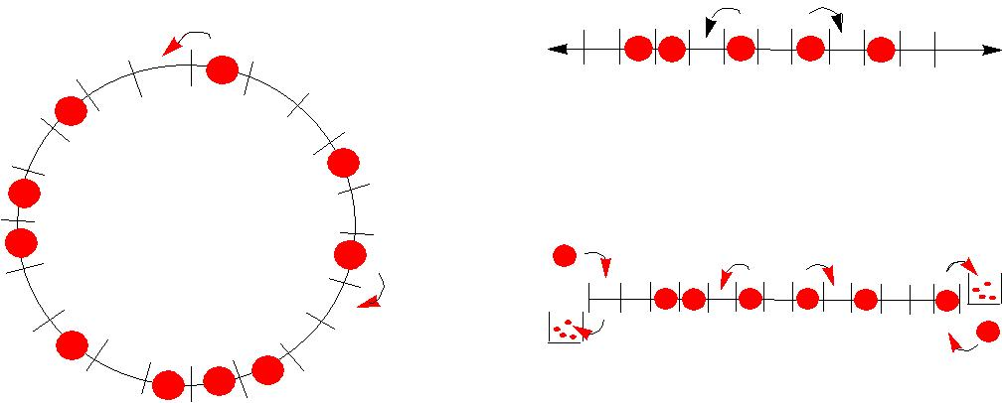
q
 |  | (b)
 | a |  | b
 | q | p | b
p
 | g |  | d
 | Left |  | right
 | reservoir |  | reservoir
(a) |  | (c)

Figure 1: Examples of ASEP with different boundary conditions. Particles perform asymmetric random walks with transition rates p to the right and q to the left, obeying particle exclusion (hard-core repulsion). (a) Periodic boundary conditions, ring of L sites with N particles. There are ^{N}C_{L} possible configurations of the system. (b) Infinite boundaries. (c) Open boundaries, with entry rate α (δ) and exit rate β(γ) on the left (right) side of the lattice.

VARIANTS OF ASEP:

- TASEP: (totally asymmetric simple exclusion process) :p=1, q=0.(Simplest model)

- PASEP: (partially asymmetric simple exclusion process): 0<p<1, 0<q<1, p≠q.

- WASEP: (weakly asymmetric simple exclusion process): p = q±δ/L; L is length of lattice.

- SSEP: (symmetric simple exclusion process): p=q.

DERIVATION OF CURRENT:

- Current is the physical quantity which signifies the flow of particles in the system, denoted by J(ρ).

- Current is produced when a particle moves from one occupies site to its next site; provided latter is vacant.

- Fundamental current-density relationship is: J(ρ) = ρ(1-ρ)

FUNDAMENTAL DIAGRAM

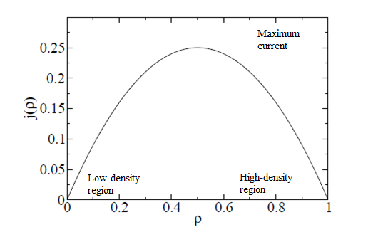

STEADY STATE SOLUTIONS:

Low density (LD) phase (α< β, α< 1/2):
- Dynamics controlled by entrance rate α.
- Bulk density ρ₁= α and current = J= α(1-α); ρ_{L} =$\frac{α(1-α)}{β}$

High-density (HD) phase (β< α, β< 1/2):
- Dynamics controlled by entrance rate β.
- Density ρ= 1- β current = J= β(1-β); ρ₁= 1-$\frac{β(1-β ) }{α}$ ρ_{L} = 1-β

Maximal current (MC) phase (α>1/2, β> 1/2):
- Dynamics independent of α as well as β
- Density ρ= ½ and current J= ¼; ρ₁= 1- $\frac{1}{4α}$ ρ_{L} =$\frac{1}{4β}$

STEADY-STATE SOLUTION: PHASE DIAGRAM

Boundary-induced phase transitions
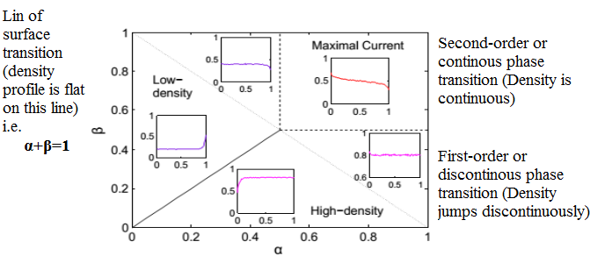

TWO-CHANNEL TASEP

- Particles move in more than one channel in many transport systems

- Interaction among two channels has to be incorporated to form a coupled two-channel ASEP.

- Examples: Vehicular traffic, Intracellular transport

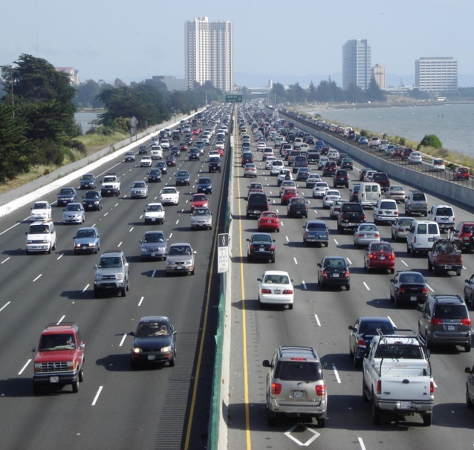

TWO KINDS OF COUPLING:

INDIRECT: Inter- channel transitions are not allowed. The hopping rates of particles in one lane depend on the configuration of the neighboring lane.
Lane-1
Lane-2
DIRECT: Particles can shift from one channel to another with certain rates obeying hard-core exclusion principle.

Direct Coupling is further classified into two parts:

- SYMMETRIC: The rate of hopping from one lane to another is same as the one from the latter to the former (w1= w2= w). Further classified as:
- Strong: w=1
- Weak : 0<w<1

- ASYMMETRIC: The rate of hopping from one lane to another is different than the one from the latter to the former (w1≠w2). Further classified as:
- Fully: The lane-changing is fully biased in one direction, i.e.w1≠0; w2= 0.
- Partially: The lane-changing rates are non-zero and unequal, i.e. w1≠ w2 ≠ 0.

THE MODEL AND DYNAMICAL RULES:

The model consists of indistinguishable particles distributed under the exclusion principle along two parallel lattice channels each of length L. Particles can move horizontally, i.e. forward and backward along the channel and inter-channel transitions are also allowed. A site is randomly selected from the two-lane system at each time step and any kind of transition is possible only when the target site is vacant. Particles can enter with a rate α_{j} in the j^{th} lane (j=1, 2) when the entrance site is empty. Particle movements in the bulk of the system are characterized by following dynamical rules. The vertical transition rates are w1 and w2 for lane-1 and lane-2, respectively. The forward and backward hopping rates of a particle on i^{th} lattice site in lane-1 depend on the occupancy state of i^{th} site in lane-2 and vice-versa. Particles in j^{th} lane (j = 1, 2) move towards right with a rate p_{j} and towards left with a rate q_{j} when the corresponding site on the neighboring lane is occupied; otherwise forward and backward hopping rates are taken as p_{j}(1−w_{j}) and q_{j}(1−w_{j}), respectively. Such a rule is defined in order to ensure that the full transition rate of the particle from a site to go backward/forward/up/down is always 1. The rate with which particles can leave the lane-1, lane 2 is β₁ and β_{2,} respectively if the exit site on the other lane is occupied otherwise the exit rate from j^{th} lane becomes β_{j}(1 − w_{j}).

A TWO CHANNEL SYMMETRICALLY COUPLED TASEP

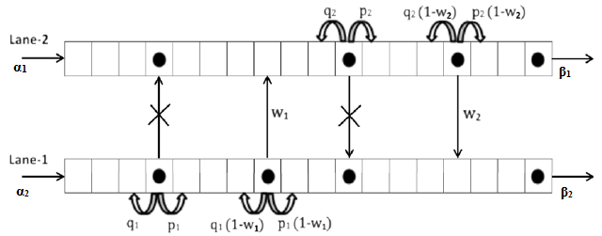

ZERO COUPLING: TRIVIAL CASE

- System decouples into two independent single-channel ASEPs.

- Three steady-state phases exist LD, HD and MC in each lane.

VERTICAL CLUSTER MEAN-FIELD APPROACH

- At any instant of time, the system exists in one of the four following vertical cluster configurations.

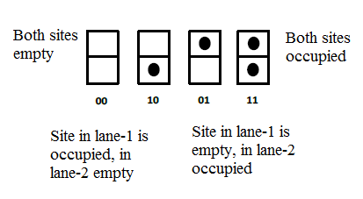

- P₀₀^{i}, P^{i}₁₀, P₀₁^{i}, P^{i}₁₁ denote probabilities of i^{th} site to be in these configurations, respectively.

- Normalization condition: P₀₀^{i} + P^{i}₁₀ + P₀₁^{i} + P^{i}₁₁ = 1.

MASTER EQUATIONS

Aim : To compute transitions going into configuration {11} and transitions going from {11} into another configuration.

Gain terms for configuration {11}:

p₂ (1-w₂)P₀₁P₁₀ q₁ (1-w₁)P₀₁P₁₀

p₁(1-w₁)P₁₀P₀₁ q₂ (1-w₂)P₀₁P₁₀

Loss terms for configuration {11}:

q₁P₁₁P₁₀ q₂P₁₁P₀₁

p₁P₁₁P₀₀ p₂P₁₁P₀₀

$\frac{dP_{11}}{dt}=$Gain terms for configuration {11} - Loss terms for configuration {1,1}

$\frac{dP_{11}}{dt}=$ ((p1+q1)(1-w1)+(p2-q2)(1-w2))P₁₀P₀₁ – (p1+p2+q1+w2)P₁₁P₀₀ (1)

$\frac{dP_{10}}{dt}=$(p1+p2+q1+q2) P₁₁P₀₀ ₊ w2P₀₁ –w1P₁₀ – ((p1+q1)(1-w1)+(p2-q2)(1- w2))P₁₀P₀₁ (2)

$\frac{dP_{10}}{dt}=$ (p1+p2+q1+q2) P₁₁P₀₀ - w2P₀₁ - ((p1+q1)(1-w1)+(p2-q2)(1-w2))P₁₀P₀₁
(3)

$\frac{dP_{00}}{dt}=$((p1+q1)(1-w1)+(p2-q2)(1-w2))P₁₀P₀₁ - (p1+p2+q1+q2) P₁₁P₀₀ (4)

In steady – state; the dynamics of the system are analyzed by solving
$\frac{dP_{11}}{dt}= \frac{dP_{10}}{dt}=\frac{dP_{10}}{dt}=\frac{dP_{00}}{dt}=0$ (5)

Due to particle-hole symmetry Eq. (5) is equivalent to the following set of equations:
- ((p1+q1)(1-w1)+(p2-q2)(1-w2))P₁₀P₀₁ = (p1+p2+q1+q2) P₁₁P₀₀ (6)

- (p1+p2+q1+q2) P₁₁P₀₀ ₊ w2P₀₁ = w1P₁₀ + ((p1+q1)(1-w1)+(p2-q2)(1- w2))P₁₀P₀₁ (7)
Solving Eqns. (6) and (7) we get w1P₁₀ - w2P₀₁ = 0 which on substituting k=w2/w1 (assuming w1 ≠ 0), further reduces to P₁₀ = kP₀₁ (8)
Here, the parameter k signifies the strength of coupling between two lanes and can be called as the binding constant. It is easy to see that k takes non-negative values and is of utmost importance in characterizing the phase diagrams for the proposed
model. In order to take into account all the possible steady-state solutions, it is sufficient to consider the case 0 ≤ k ≤ 1. Using the fact that the current in the system is produced only due to horizontal transitions, we compute the steady-state
currents in the bulk as well as at the boundaries given by

Jent,1 = α₁(P₀₁ + P₀₀) (9a)

Jent,2 = α₂(P₁₀ + P₀₀) (9b)

Jbulk,1 = (p1 − q1)(P₁₁ + (1 − w1)P₁₀)(1 − P₁₁ − P₁₀) (9c)

Jbulk,2 = (p2 − q2)(P₁₁ + (1 − w2)P₀₁)(1 − P₁₁ − P₀₁) (9d)

Jexit,1 = β₁(P₁₁ + (1 − w1)P₁₀) (9e)

Jexit,2 = β₂(P₁₁ + (1 − w2)P₀₁) (9f)

PHASE DIAGRAMS AND MONTE-CARLO SIMULATIONS

In this section, we determine the phase diagrams of the proposed model for different values of binding constant. In addition to this, the theoretical arguments are justified with the help of extensive Monte-Carlo simulations for a system of
size L = 100. We have also verified our results for L = 1000 and observed that finite-size effects can be neglected, as in our case the computational results are found to be independent of lattice size. The simulations are carried out for 109–1010 time steps and first 5% steps are ignored to ensure the occurrence of steady-state. Although theoretical results obtained are valid for all values of p1, q1, p2 and q2, yet we have assumed p1 + q1 = p2 + q2 = 1.
SYMMETRIC COUPLING (k=1)

When inter-channel transition rates are same for both the lanes, we get w1 = w2 = w (say) and Eq. (8) gives

P₁₀ = P₀₁ (10)

Based upon the strength of inter-channel transitions, one can further analyze the system in terms of strong (w = 1) and intermediate (0 < w < 1) couplings. The important difference in the analysis of strong and intermediate coupling cases is that our system cannot be mapped onto an effective single-lane ASEP in the latter case in contrast to the former one. This motivates us to study the effect of symmetric coupling by segmenting this case into two subcases: (a) w = 1 and (b) 0 < w < 1.

STRONG SYMMETRIC COUPLING

In a coupled dynamical system, two channels are said to be strongly coupled when the number of inter-channel hoppings is much higher as compared to horizontal movements. Here, the parameter w takes the value unity. In terms of particle dynamics, we can infer that whenever lane changing is permissible due to the configuration of the lanes, particles prefer to hop vertically. Under this case, Eqs. (6) and (7) simplify to P11P00 = 0 which leads to the following discussion.

Case 1: When P₁₁ = 0, there does not exist any fully-filled vertical cluster in the system. Under this condition, we have

Jent, 1 = α₁(P₀₁ + P₀₀)

Jent, 2 = α₂(P₀₁ + P₀₀);

Jbulk, 1 = Jbulk,2 = Jexit,1 = Jexit,2 = 0 (11)

Since the total current in the system must satisfy Jtotal = Jent,1+Jent,2 = Jbulk,1+Jbulk,2 = Jexit,1+Jexit,2, we get (α₁₊ α₂ )(P₀₁+P₀₀) = 0. Equivalently, P₁₀ = P₀₁ = P₀₀ = 0 which violates the normalization condition. Hence, we conclude that the probability of finding a fully-filled vertical cluster is never zero. The infeasibility of this case is also justified with the proposed dynamical rules. Suppose the only vertical cluster configurations in the system are half-filled and empty. Whenever a particle is selected for transition, it lies in one of the sites of half-filled cluster and due to strong coupling it will definitely make a vertical transition and shift to the other lane. Thus on the whole, there are no horizontal movements of particles in the system which leads to zero current. As particles are being injected in the system at the entrance with non-zero rate α₁ and α₂, the bulk current in the system cannot be zero.

Case 2: Consider the case in which the probability of finding an empty vertical cluster is zero i.e. P₀₀ = 0. Further, taking into account the conclusion from case 1, Eqs. (9a)–(9f) reduce to

Jent,1 = α₁P₁₀ (12a)

Jent,2 = α₂P₀₁ (12b)

Jbulk,1 =$\frac{p1 - q1}{2}$P₁₁(1 − P₁₁) (12c)

Jbulk,2 =$\frac{p2 - q2}{2}$P₁₁(1 − P₁₁) (12d)

Jexit,1 = β₁P₁₁ (12e)

Jexit,2 = β₂P₁₁. (12f)

In this case, the only possible configurations of vertical clusters in the system are half-filled and fully-filled. Now, the coupled two-lane ASEP can be mapped into an effective single-lane ASEP treating {11} as new effective particles and {10}
as new effective holes with α_{eff} =$\frac{α1+ α2}{2}$, β_{eff} = β₁ + β₂ as effective entrance and exit rates, respectively [33]. Here, the respective effective forward and backward hopping rates are given by p_{eff} = $\frac{p1+p2}{2}$ and q_{eff} = $\frac{q1+q2}{2}$. Recalling the known results for the dynamics of a single-lane ASEP, we predict the existence of three general stationary phases in the phase diagram. These phases are low-density, high-density and maximal current denoted by (LD, LD), (HD, HD) and (MC, MC), respectively. The steady-state properties of these phases are listed in given Table Steady-state properties of the system in strong symmetric coupling conditions

Phase | Condition of  existence | P₁₁ | Total current
(LD, LD) | $\frac{α1+ α2}{2}$ < min(β₁ + β₂, $\frac{peff-qeff}{2}$ ,) | $$\frac{α1+ α2}{2(peff-qeff)}$$ | $$(\frac{α1+ α2}{2})\{1-\frac{α1+ α2}{2\left(peff-qeff\right)}\}$$
(HD, HD) | β₁ + β₂<min($\frac{α1+ α2}{2},$ $\frac{peff-qeff}{2}$ ) | $$1-\frac{β1 + β2}{(peff-qeff)}$$ | $$(β1 + β2)\{1-\frac{β1 + β2}{\left(peff-qeff\right)}\}$$
(MC, MC) | $\frac{peff-qeff}{2}$ <min ($\frac{α1+ α2}{2},β1 + β2$) | 1/2 | $$\frac{(peff-qeff)}{4}$$

RESULTS

- We performed Monte-Carlo simulations varying α₁, α₂, β₁, β₂. We took different combinations of parameters and found out that bulk density is just dependent on p_{eff} not on individual p₁ and p_{2,} similarly we also found out that it is only dependent on α_{eff}, β_{eff} , not on individual parameters.

- Fig1. LD phase for w=1.0 β_{eff} =0.3(β₁= 0.1 β₂=0.2) α_{eff}=0.08(α₁=0.07 α₂=0.09) p_{eff}=0.6
(a) p₁=0.8 p₂=0.4
(b) p₁=1.0 p₂=0.2

Fig1. HD phase for w=1.0 β_{eff} =0.16(β₁= 0.07 β₂=0.09) α_{eff}=0.8(α₁=0.7 α₂=0.9) p_{eff}=0.6
(a) p₁=0.8 p₂=0.4

(b) p₁=1.0 p₂=0.2

Fig1. MC phase for w=1.0 β_{eff} =(β₁= 0.8 β₂=0.3) α_{eff}=0.8(α₁=0.7 α₂=0.9) p_{eff}=0.6
(a)p₁=0.8 p₂=0.4

(b) p₁=1.0 p₂=0.2

*Density profile depends only on p_{eff} not on individual p₁ and p_{2.}

Fig2. LD phase for w=1.0 p_{eff}=1.0
- β_{eff} =0.2(β₁=0.05 β₂=0.15) α_{eff}=0.15(α₁=0.1 α₂=0.2)
(b) β_{eff} =0.2(β₁=0.05 β₂=0.15) α_{eff}=0.15(α₁=0.06 α₂=0.24)

Fig2. HD phase for w=1.0 p_{eff}=1.0
- β_{eff} =0.25(β₁=0.2 β₂=0.05) α_{eff}=0.3(α₁=0.4 α₂=0.2)

(b) β_{eff} =0.2(β₁=0.1 β₂=0.15) α_{eff}=0.15(α₁=0.4 α₂=0.2)

Fig3. MC phase for w=1.0 p_{eff}=1.0
- β_{eff} =0.75(β₁=0.05 β₂=0.7) α_{eff}=0.7(α₁=0.5 α₂=0.9)
- β_{eff} =0.75(β₁=0.55 β₂=0.2) α_{eff}=0.7(α₁=0.6 α₂=0.8)

*bulk denstity only depends on α_{eff} and β_{eff} , do not on individual β₁ , β₂ , α₁ , α₂

Fig1. LD phase for w=1.0 p_{eff}=1.0
- β_{eff} =0.4(β₁=β₂=0.2) α_{eff}=0.2(α₁=0.1 α₂=0.3)

(b) β_{eff} =0.4(β₁=β₂=0.2) α_{eff}=0.2(α₁=α₂=0.2)

(c) β_{eff} =0.7(β₁=0.5 β₂=0.2) α_{eff}=0.25(α₁=α₂=0.25)

(d)β_{eff} =0.7(β₁=0.35 β₂=0.35) α_{eff}=0.25(α₁=α₂=0.25)

*keeping α₁ , α₂ same but different β₁ , β₂ gives the sames results if we keep same α₁ , α₂ as well as β₁ , β₂

Fig2. HD phase for w=1.0 p_{eff}=1.0
- β_{eff} =0.24(β₁=β₂=0.12) α_{eff}=0.3(α₁=0.4 α₂=0.2)

(b) β_{eff} =0.24(β₁=β₂=0.12) α_{eff}=0.3(α₁=0.3 α₂=0.3)

(c)β_{eff} =0.45(β₁=0.2 β₂=0.25) α_{eff}=0.6(α₁=α₂=0.6)

(d) β_{eff} =0.45(β₁=β₂=0.225) α_{eff}=0.6(α₁=α₂=0.6)
*keeping α₁ , α₂ same but different β₁ , β₂ gives the sames results if we keep same α₁ , α₂ as well as β₁ , β₂

Fig3. MC phase for w=1.0 p_{eff}=1.0
- β_{eff} =0.6(β₁=β₂=0.3) α_{eff}=0.65(α₁=0.8 α₂=0.5)

(a) β_{eff} =0.6(β₁=β₂=0.3) α_{eff}=0.65(α₁=0.65 α₂=0.65)
- β_{eff} =0.6(β₁=0.4 β₂=0.2) α_{eff}=0.7(α₁=α₂=0.7)

(d) β_{eff} =0.6(β₁=0.3 β₂=0.3) α_{eff}=0.7(α₁=α₂=0.7)

*keeping α₁ , α₂ same but different β₁ , β₂ gives the sames results if we keep same α₁ , α₂ as well as β₁ , β₂ .

INTERMEDIATE SYMMETRIC COUPLING
In this subcase, we discuss how intermediate values of lane-changing rate (0 < w < 1) affect the steady-state properties of the system. The currents at the entrance as well as exit are same for both the channels whereas the bulk currents in two channels differ due to unequal horizontal hopping rates. The expressions for the bulk and boundary currents (per channel)

Jent,1 = α1(P₁₀+P₀₀)_ (13a)

Jent,2 = α₂(P₀₁+P₀₀)_ (13b)

Jbulk,1 = (p1-q1)(P₁₁ + (1-w)P₁₀)(1-p₁₁-P₁₀) (13c)

Jbulk,2 =(p1-q1)(P₁₁ + (1-w)P₁₀)(1-p₁₁-P₁₀ ) (13d)

Jexit,1 = β₁(P₁₁+(1-w)P₁₀) (13e)

Jexit,2 = β₂(P₁₁+(1-w)P₀₁) (13f)

The vertical cluster state probabilities P10, P00 as well as the bulk density per channel can be expressed in terms of the probability of the fully-filled vertical cluster P11 as follows:

P₁₀ = $\frac{-P11+\sqrt{P11(1-w+wP11})}{1-w}$

P₀₀ = 1 + $\frac{1+w}{1-w}$ P₁₁ - 2$\frac{\sqrt{P11(1-w+wP11)}}{1-w}$

ρ_{bulk} = $\frac{-wP11+\sqrt{P11(1-w+wP11})}{1-w}$

As clear from the above expressions, it is sufficient to find the value of P₁₁ in order to investigate the properties of the system and hence, P₁₁ can be taken as the order parameter.

- (LD, LD): In low-density phase, the overall dynamics of the system is dominated by entrance current. Thus the total current in the system satisfies Jent,1 + Jent,2 = Jbulk,1 + Jbulk,2 which leads to

P_{11,LD =} $\frac{-\left(1-w\right)+\sqrt{({1-w)}^{2}+4w{\frac{(α1+ α2)}{4a^{2}}}^{2}}}{2w}$

Where a = $\frac{p1+p2-q1-q2}{2}$

The total current in this phase is given by

J_{LD} = ($α1+ α2$)($\frac{1-w+wP11+\sqrt{P11(1-w+wP11})}{1-w}$)

- (HD, HD): In high-density phase, only exit dynamics affect the stationary-state behavior. The total current in the system satisfies Jexit,1 + Jexit,2 = Jbulk,1 + Jbulk,2. On similar lines, we determine the following expression for P₁₁,_{HD}:

P_{11,HD =} 1- $\frac{β1 + β2}{2a}$ – ($\frac{1-\sqrt{1-4w(\frac{β1 + β2}{2a})(1-\frac{β1 + β2}{2a})}}{2w}$)

The total current in this phase is given by

J_{HD} = ($β1 + β2$) ($\sqrt{P11(1-w+wP11}$))

- (MC, MC): The current in the system will be maximum in this phase and is given by

J_{MC} = (p1 + p2 − q1 − q2) $\frac{\sqrt{P11{(1 - w + wP11)}^{1.5} - P11(1 - w + wP11)}}{1-w}$

RESULTS

LD phase for w=0.8 (β₁= 0.5 β₂=0.8) (α₁=α₂=0.2) p₁+p₂=1.8
- p₁=0.9 p₂=0.9

(b)p₁=1.0 p₂=0.8
*Same results for α₁ α₂ different and β₁ β₂ same

HD phase for w=0.8 (β₁=β₂=0.2) (α₁=0.5 α₂=0.8) p₁+p₂=1.8
(a)p₁=0.9 p₂=0.9

(b) p₁=1.0 p₂=0.8
*Same results for α₁ α₂ same and β₁ β₂ different

*Density profiles in LD and HD depends only on p_{eff} not on individual p₁ and p₂.

LD phase for w=1.0 (β₁=β₂=0.6) (α₁=0.8 α₂=0.2) p₁+p₂=1.6
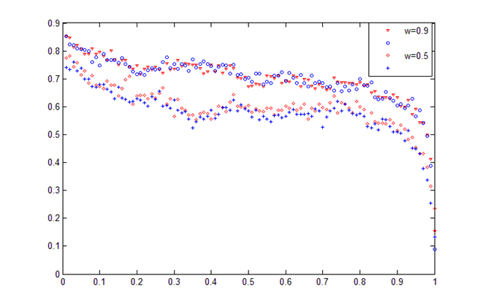

HD phase for w=1.0 (β₁=0.8 β₂=0.2) (α₁=α₂=0.6) p₁+p₂=1.6
*density depends on coupling rates i.e. w. More the coupling rate more is the bulk density.

Dependence of bulk current on transition rates. We further explore the case of symmetric coupling by studying the impact of transition rates on bulk currents in the system. The bulk currents computed with the help of vertical cluster mean-field theory are shown in the Fig. The following conclusions can be drawn

- For a fixed value of w, the decrease in the magnitude of parameter p1 + p2 reduces the number of forward direction particle hoppings as compared to that in backward direction which leads to a net decrease in the bulk current. Moreover, in LD phase, the value of $α1+ α2$ which gives the maximum current is also falling down (Fig. (a)). It is due to the decrease in the magnitude of maximal current as the smaller value of current is achieved for comparatively lower values of α by the system. In addition, the decrease in the value of p1 +p2 leads to shrinking the range of α for LD phase. It is easy to verify from Eq. (15) that P_{11,LD} is well defined only when α ≤ (p1 + p2 − (q1 + q2))/2 which requires lesser value of α with the decrease in the value of p1 + p2 − (q1 + q2). Similar arguments hold to justify the effect of these parameters for HD phase (Fig.(b)).

(a)
$$α1+ α2$$

(b)
.
$$β1 + β2$$

Bulk current for different horizontal transition rates for LD and HD phases in (a) and (b), respectively for w = 0.5
PHASE DIAGRAM:
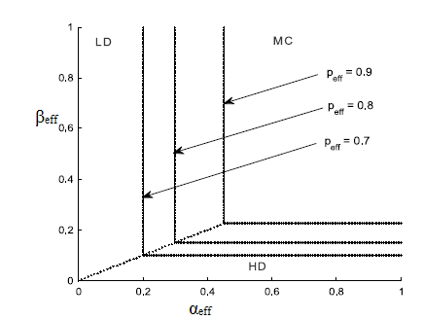
Phase diagram for w = 1 with different values of p_{eff}

SUMMARY AND CONCLUSION
We have presented a detailed description of a two-channel coupled ASEP with dependency of intra-channel transition rates on the configuration of neighboring lane for general values of the involved parameters. The model is theoretically analyzed using the vertical cluster mean-field approach and numerically with the help of Monte-Carlo simulations. The system can be studied exactly via its mapping into an effective single-lane ASEP in the case of strong symmetric inter-channel coupling. It is observed that in the limits of strong as well as weak coupling, symmetric particle exchange between two channels gives rise to three stationary phases in the phase diagram. The effect of changing horizontal transition rates on phase diagram and current in the system is also examined and it is found that the decrease in the value of sum of forward moving rates not only leads to shrinking of LD and HD phases but also lowers the magnitude of bulk current in the system. Regarding the effect of coupling strength on the bulk current, one can conclude that higher magnitude of lane-changing rate lowers the particle
current.

REFERENCES
- Coupling of two asymmetric exclusion processes with open boundaries
AK Gupta, I Dhiman - Physica A: Statistical Mechanics and its Applications, 2013
- E. Pronina, A.B. Kolomeisky, Physica A 372 (2006) 12.
- E. Pronina, A.B. Kolomeisky, J. Phys. A: Math. Gen. 37 (2004) 9907.
- E. Pronina, A.B. Kolomeisky, J. Phys. A 40 (2007) 2275.

